|  |  |
| --- | --- |
| A picture of a winding road and trees  PRACTICAL ASSIGNMENT 2 | Oarabile Makwe Mahalefa  ADDB6311 |

QUESTION 1

CREATE TABLE CUSTOMER (

CUSTOMER_ID NUMBER PRIMARY KEY,

FIRST_NAME VARCHAR2(50),

SURNAME VARCHAR2(50),

ADDRESS VARCHAR2(100),

CONTACT_NUMBER VARCHAR2(15),

EMAIL VARCHAR2(100)

);

-- Populate CUSTOMER table

INSERT INTO CUSTOMER (CUSTOMER_ID, FIRST_NAME, SURNAME, ADDRESS, CONTACT_NUMBER, EMAIL)

VALUES (11011, 'Jack', 'Smith', '18 Water Rd', '0877277521', 'jsmith@isat.com');

INSERT INTO CUSTOMER (CUSTOMER_ID, FIRST_NAME, SURNAME, ADDRESS, CONTACT_NUMBER, EMAIL)

VALUES (11012, 'Pat', 'Hendricks', '22 Water Rd', '0863257857', 'ph@mcom.co.za');

INSERT INTO CUSTOMER (CUSTOMER_ID, FIRST_NAME, SURNAME, ADDRESS, CONTACT_NUMBER, EMAIL)

VALUES (11013, 'Andre', 'Clark', '101 Summer Lane', '0834567891', 'aclark@mcom.co.za');

INSERT INTO CUSTOMER (CUSTOMER_ID, FIRST_NAME, SURNAME, ADDRESS, CONTACT_NUMBER, EMAIL)

VALUES (11014, 'Kevin', 'Jones', '55 Mountain way', '0612547895', 'kj@isat.co.za');

INSERT INTO CUSTOMER (CUSTOMER_ID, FIRST_NAME, SURNAME, ADDRESS, CONTACT_NUMBER, EMAIL)

VALUES (11015, 'Lucy', 'Williams', '5 Main rd', '0827238521', 'lw@mcal.co.za');

SELECT * FROM Customer;

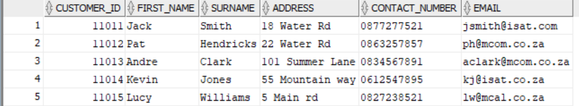

-- Create EMPLOYEE table

CREATE TABLE EMPLOYEE (

EMPLOYEE_ID VARCHAR2(10) PRIMARY KEY,

FIRST_NAME VARCHAR2(50),

SURNAME VARCHAR2(50),

CONTACT_NUMBER VARCHAR2(15),

ADDRESS VARCHAR2(100),

EMAIL VARCHAR2(100)

);

-- Populate EMPLOYEE table

INSERT INTO EMPLOYEE (EMPLOYEE_ID, FIRST_NAME, SURNAME, CONTACT_NUMBER, ADDRESS, EMAIL)

VALUES ('emp101', 'Jeff', 'Davis', '0877277521', '10 main road', 'jand@isat.com');

INSERT INTO EMPLOYEE (EMPLOYEE_ID, FIRST_NAME, SURNAME, CONTACT_NUMBER, ADDRESS, EMAIL)

VALUES ('emp102', 'Kevin', 'Marks', '0837377522', '18 water road', 'km@isat.com');

INSERT INTO EMPLOYEE (EMPLOYEE_ID, FIRST_NAME, SURNAME, CONTACT_NUMBER, ADDRESS, EMAIL)

VALUES ('emp103', 'Adanya', 'Andrews', '0817117523', '21 circle lane', 'aa@isat.com');

INSERT INTO EMPLOYEE (EMPLOYEE_ID, FIRST_NAME, SURNAME, CONTACT_NUMBER, ADDRESS, EMAIL)

VALUES ('emp104', 'Adebayo', 'Dryer', '0797215244', '1 sea road', 'aryer@isat.com');

INSERT INTO EMPLOYEE (EMPLOYEE_ID, FIRST_NAME, SURNAME, CONTACT_NUMBER, ADDRESS, EMAIL)

VALUES ('emp105', 'Xolani', 'Samson', '0827122255', '12 main road', 'xosam@isat.com');

SELECT * FROM EMPLOYEE;

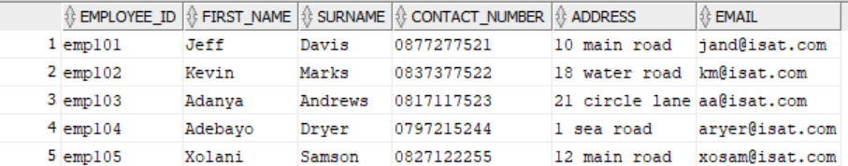

-- Create DONATOR table

CREATE TABLE DONATOR (

DONATOR_ID NUMBER PRIMARY KEY,

FIRST_NAME VARCHAR2(50),

SURNAME VARCHAR2(50),

CONTACT_NUMBER VARCHAR2(15),

EMAIL VARCHAR2(100)

);

-- Populate DONATOR table

INSERT INTO DONATOR (DONATOR_ID, FIRST_NAME, SURNAME, CONTACT_NUMBER, EMAIL)

VALUES (20111, 'Jeff', 'Watson', '0827172250', 'jwatson@ymail.com');

INSERT INTO DONATOR (DONATOR_ID, FIRST_NAME, SURNAME, CONTACT_NUMBER, EMAIL)

VALUES (20112, 'Stephen', 'Jones', '0837865670', 'joness@ymail.com');

INSERT INTO DONATOR (DONATOR_ID, FIRST_NAME, SURNAME, CONTACT_NUMBER, EMAIL)

VALUES (20113, 'James', 'Joe', '0878978650', 'jj@isat.com');

INSERT INTO DONATOR (DONATOR_ID, FIRST_NAME, SURNAME, CONTACT_NUMBER, EMAIL)

VALUES (20114, 'Kelly', 'Ross', '0826575650', 'kross@gsat.com');

INSERT INTO DONATOR (DONATOR_ID, FIRST_NAME, SURNAME, CONTACT_NUMBER, EMAIL)

VALUES (20115, 'Abraham', 'Clark', '0797656430', 'aclark@ymail.com');

SELECT * FROM DONATOR;

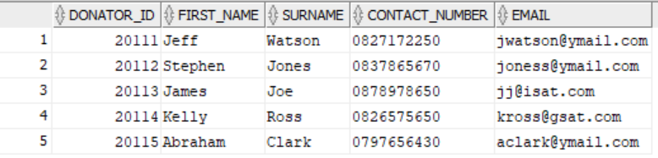

-- Create DONATION table

CREATE TABLE DONATION (

DONATION_ID NUMBER PRIMARY KEY,

DONATOR_ID NUMBER,

DONATION VARCHAR2(100),

PRICE NUMBER,

DONATION_DATE DATE,

FOREIGN KEY (DONATOR_ID) REFERENCES DONATOR(DONATOR_ID)

);

-- Populate DONATION table

INSERT INTO DONATION (DONATION_ID, DONATOR_ID, DONATION, PRICE, DONATION_DATE)

VALUES (7111, 20111, 'KIC Fridge',599, TO_DATE('2024-05-01', 'YYYY-MM-DD'));

INSERT INTO DONATION (DONATION_ID, DONATOR_ID, DONATION, PRICE, DONATION_DATE)

VALUES (7112, 20112, 'Samsung 42inch LCD', 1299, TO_DATE('2024-05-03', 'YYYY-MM-DD'));

INSERT INTO DONATION (DONATION_ID, DONATOR_ID, DONATION, PRICE, DONATION_DATE)

VALUES (7113, 20113, 'Sharp Microwave', 1599, TO_DATE('2024-05-03', 'YYYY-MM-DD'));

INSERT INTO DONATION (DONATION_ID, DONATOR_ID, DONATION, PRICE, DONATION_DATE)

VALUES (7114, 20115, '6 Seat Dining room table',799, TO_DATE('2024-05-05', 'YYYY-MM-DD'));

INSERT INTO DONATION (DONATION_ID, DONATOR_ID, DONATION, PRICE, DONATION_DATE)

VALUES (7115, 20114, 'Lazyboy Sofa', 1199, TO_DATE('2024-05-07', 'YYYY-MM-DD'));

INSERT INTO DONATION (DONATION_ID, DONATOR_ID, DONATION, PRICE, DONATION_DATE)

VALUES (7116, 20113, 'JVC Surround Sound System', 179, TO_DATE('2024-05-09', 'YYYY-MM-DD'));

SELECT * FROM DONATION;

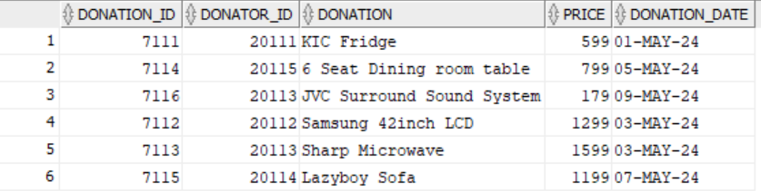

-- Create DELIVERY table

CREATE TABLE DELIVERY (

DELIVERY_ID NUMBER PRIMARY KEY,

DELIVERY_NOTES VARCHAR2(100),

DISPATCH_DATE DATE,

DELIVERY_DATE DATE

);

-- Populate DELIVERY table

INSERT INTO DELIVERY (DELIVERY_ID, DELIVERY_NOTES, DISPATCH_DATE, DELIVERY_DATE)

VALUES (511, 'Double packaging requested', TO_DATE('2024-05-10', 'YYYY-MM-DD'), TO_DATE('2024-05-15', 'YYYY-MM-DD'));

INSERT INTO DELIVERY (DELIVERY_ID, DELIVERY_NOTES, DISPATCH_DATE, DELIVERY_DATE)

VALUES (512, 'Delivery to work address', TO_DATE('2024-05-12', 'YYYY-MM-DD'), TO_DATE('2024-05-15', 'YYYY-MM-DD'));

INSERT INTO DELIVERY (DELIVERY_ID, DELIVERY_NOTES, DISPATCH_DATE, DELIVERY_DATE)

VALUES (513, 'Signature required', TO_DATE('2024-05-12', 'YYYY-MM-DD'), TO_DATE('2024-05-17', 'YYYY-MM-DD'));

INSERT INTO DELIVERY (DELIVERY_ID, DELIVERY_NOTES, DISPATCH_DATE, DELIVERY_DATE)

VALUES (514, 'No notes', TO_DATE('2024-05-12', 'YYYY-MM-DD'), TO_DATE('2024-05-15', 'YYYY-MM-DD'));

INSERT INTO DELIVERY (DELIVERY_ID, DELIVERY_NOTES, DISPATCH_DATE, DELIVERY_DATE)

VALUES (515, 'Birthday present wrapping required', TO_DATE('2024-05-18', 'YYYY-MM-DD'), TO_DATE('2024-05-19', 'YYYY-MM-DD'));

INSERT INTO DELIVERY (DELIVERY_ID, DELIVERY_NOTES, DISPATCH_DATE, DELIVERY_DATE)

VALUES (516, 'Delivery to work address', TO_DATE('2024-05-20', 'YYYY-MM-DD'), TO_DATE('2024-05-25', 'YYYY-MM-DD'));

SELECT * FROM DELIVERY;

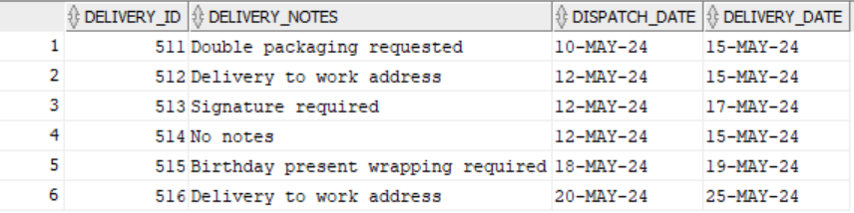

-- Create RETURNS table

CREATE TABLE RETURNS (

RETURN_ID VARCHAR2(10) PRIMARY KEY,

RETURN_DATE DATE,

REASON VARCHAR2(100),

CUSTOMER_ID NUMBER,

DONATION_ID NUMBER,

EMPLOYEE_ID VARCHAR2(10),

FOREIGN KEY (CUSTOMER_ID) REFERENCES CUSTOMER(CUSTOMER_ID),

FOREIGN KEY (DONATION_ID) REFERENCES DONATION(DONATION_ID),

FOREIGN KEY (EMPLOYEE_ID) REFERENCES EMPLOYEE(EMPLOYEE_ID)

);

-- Populate RETURNS table

INSERT INTO RETURNS (RETURN_ID, RETURN_DATE, REASON, CUSTOMER_ID, DONATION_ID, EMPLOYEE_ID)

VALUES ('ret001', TO_DATE('2024-05-25', 'YYYY-MM-DD'), 'Customer not satisfied with product', 11011, 7116, 'emp101');

INSERT INTO RETURNS (RETURN_ID, RETURN_DATE, REASON, CUSTOMER_ID, DONATION_ID, EMPLOYEE_ID)

VALUES ('ret002', TO_DATE('2024-05-25', 'YYYY-MM-DD'), 'Product had broken section', 11013, 7114, 'emp103');

SELECT * FROM RETURNS;



-- Create INVOICE table

CREATE TABLE INVOICE (

INVOICE_NUM NUMBER PRIMARY KEY,

CUSTOMER_ID NUMBER,

INVOICE_DATE DATE,

EMPLOYEE_ID VARCHAR2(10),

DONATION_ID NUMBER,

DELIVERY_ID NUMBER,

FOREIGN KEY (CUSTOMER_ID) REFERENCES CUSTOMER(CUSTOMER_ID),

FOREIGN KEY (EMPLOYEE_ID) REFERENCES EMPLOYEE(EMPLOYEE_ID),

FOREIGN KEY (DONATION_ID) REFERENCES DONATION(DONATION_ID),

FOREIGN KEY (DELIVERY_ID) REFERENCES DELIVERY(DELIVERY_ID)

);

-- Populate INVOICE table

INSERT INTO INVOICE (INVOICE_NUM, CUSTOMER_ID, INVOICE_DATE, EMPLOYEE_ID, DONATION_ID, DELIVERY_ID)

VALUES (8111, 11011, TO_DATE('2024-05-15', 'YYYY-MM-DD'), 'emp103', 7111, 511);

INSERT INTO INVOICE (INVOICE_NUM, CUSTOMER_ID, INVOICE_DATE, EMPLOYEE_ID, DONATION_ID, DELIVERY_ID)

VALUES (8112, 11013, TO_DATE('2024-05-15', 'YYYY-MM-DD'), 'emp101', 7114, 512);

INSERT INTO INVOICE (INVOICE_NUM, CUSTOMER_ID, INVOICE_DATE, EMPLOYEE_ID, DONATION_ID, DELIVERY_ID)

VALUES (8113, 11012, TO_DATE('2024-05-17', 'YYYY-MM-DD'), 'emp101', 7112, 513);

INSERT INTO INVOICE (INVOICE_NUM, CUSTOMER_ID, INVOICE_DATE, EMPLOYEE_ID, DONATION_ID, DELIVERY_ID)

VALUES (8114, 11015, TO_DATE('2024-05-17', 'YYYY-MM-DD'), 'emp102', 7113, 514);

INSERT INTO INVOICE (INVOICE_NUM, CUSTOMER_ID, INVOICE_DATE, EMPLOYEE_ID, DONATION_ID, DELIVERY_ID)

VALUES (8115, 11011, TO_DATE('2024-05-17', 'YYYY-MM-DD'), 'emp102', 7115, 515);

INSERT INTO INVOICE (INVOICE_NUM, CUSTOMER_ID, INVOICE_DATE, EMPLOYEE_ID, DONATION_ID, DELIVERY_ID)

VALUES (8116, 11015, TO_DATE('2024-05-18', 'YYYY-MM-DD'), 'emp103', 7116, 516);

SELECT * FROM INVOICE;

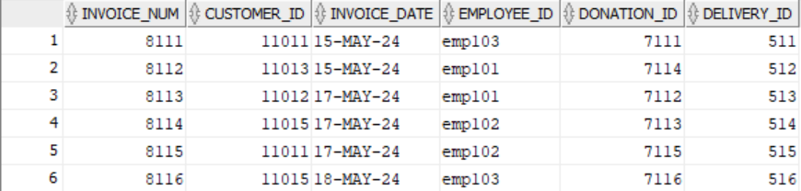

QUESTION 2

SELECT m.FIRST_NAME || ' ' || m.SURNAME AS CUSTOMER_NAME, i.EMPLOYEE_ID, d.DELIVERY_NOTES, dn.DONATION AS DONATION_PURCHASED, i.INVOICE_NUM, i.INVOICE_DATE

FROM INVOICE i

JOIN CUSTOMER m ON i.CUSTOMER_ID = m.CUSTOMER_ID

JOIN DELIVERY d ON i.DELIVERY_ID = d.DELIVERY_ID

JOIN DONATION dn ON i.DONATION_ID = dn.DONATION_ID

WHERE i.INVOICE_DATE < TO_DATE('2024-05-18', 'YYYY-MM-DD');

Output:

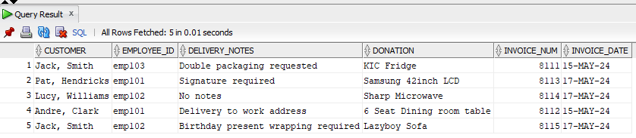

QUESTION 3

Create sequence for generating unique IDs

CREATE SEQUENCE funding_seq START WITH 1 INCREMENT BY 1;

-- Create the Funding table

CREATE TABLE Funding (

funding_id NUMBER PRIMARY KEY,

funder VARCHAR2(50),

funding_amount NUMBER(10, 2)

);

-- Create trigger to automatically generate unique ID

CREATE OR REPLACE TRIGGER funding_trigger

BEFORE INSERT ON Funding

FOR EACH ROW

BEGIN

SELECT funding_seq.nextval INTO :new.funding_id FROM dual;

END;

Output:

SELECT * FROM FUNDING;

QUESTION 4

Source Code:

SET SERVEROUTPUT ON;

DECLARE

m_customer_name VARCHAR2(100);

m_donation_purchased VARCHAR2(100);

m_donation_price VARCHAR2(10);

m_return_reason VARCHAR2(100);

CURSOR INFO IS

SELECT cu.FIRST_NAME || ' ' || cu.SURNAME AS CUSTOMER_NAME, dn.DONATION AS DONATION_PURCHASED, dn.PRICE AS DONATION_PRICE, r.REASON AS RETURN_REASON

FROM RETURNS r

INNER JOIN CUSTOMER cu ON r.CUSTOMER_ID = cu.CUSTOMER_ID

INNER JOIN DONATION dn ON r.DONATION_ID = dn.DONATION_ID;

BEGIN

FOR rec IN INFO

LOOP

m_customer_name := rec.CUSTOMER_NAME;

m_donation_purchased := rec.DONATION_PURCHASED;

m_donation_price := rec.DONATION_PRICE;

m_return_reason := rec.RETURN_REASON;

-- Display the all information

DBMS_OUTPUT.PUT_LINE('Customer Name: ' || m_customer_name);

DBMS_OUTPUT.PUT_LINE('Donation Purchased: ' || m_donation_purchased);

DBMS_OUTPUT.PUT_LINE('Donation Price: ' || m_donation_price);

DBMS_OUTPUT.PUT_LINE('Return Reason: ' || m_return_reason);

DBMS_OUTPUT.PUT_LINE('------------------------------------');

END LOOP;

END;

Output:

QUESTION 5

SET SERVEROUTPUT ON;

DECLARE

m_customer_name VARCHAR2(100);

m_employee_name VARCHAR2(100);

m_donation VARCHAR2(100);

m_dispatch_date DATE;

m_delivery_date DATE;

m_days_between NUMBER;

CURSOR INFO IS

SELECT c.FIRST_NAME || ' ' || c.SURNAME AS CUSTOMER_NAME, e.FIRST_NAME || ' ' || e.SURNAME AS EMPLOYEE_NAME,dn.DONATION,me.DISPATCH_DATE,me.DELIVERY_DATE,

CASE

WHEN c.CUSTOMER_ID = 11013 THEN me.DELIVERY_DATE - me.DISPATCH_DATE

ELSE NULL

END AS DAYS_BETWEEN

FROM INVOICE i, CUSTOMER c, DELIVERY me, EMPLOYEE e, DONATION dn

WHERE i.CUSTOMER_ID = c.CUSTOMER_ID

AND i.DELIVERY_ID = me.DELIVERY_ID

AND i.EMPLOYEE_ID = e.EMPLOYEE_ID

AND i.DONATION_ID = dn.DONATION_ID

AND i.CUSTOMER_ID = 11013;

BEGIN

FOR rec IN INFO

LOOP

m_customer_name := rec.CUSTOMER_NAME;

m_employee_name := rec.EMPLOYEE_NAME;

m_donation := rec.DONATION;

m_dispatch_date := rec.DISPATCH_DATE;

m_delivery_date := rec.DELIVERY_DATE;

m_days_between := rec.DAYS_BETWEEN;

-- Display the information

DBMS_OUTPUT.PUT_LINE('Customer: ' || m_customer_name);

DBMS_OUTPUT.PUT_LINE('Employee: ' || m_employee_name);

DBMS_OUTPUT.PUT_LINE('Donation: ' || m_donation);

DBMS_OUTPUT.PUT_LINE('Dispatch Date: ' || TO_CHAR(m_dispatch_date, 'YYYY-MM-DD'));

DBMS_OUTPUT.PUT_LINE('Delivery Date: ' || TO_CHAR(m_delivery_date, 'YYYY-MM-DD'));

-- Display the number of days that separate customer 11013's dispatch and delivery.

IF m_customer_name = 'Andre Clark' THEN

DBMS_OUTPUT.PUT_LINE('Days To Delivery: ' || m_days_between);

END IF;

DBMS_OUTPUT.PUT_LINE('------------------------------------');

END LOOP;

END;

Output:

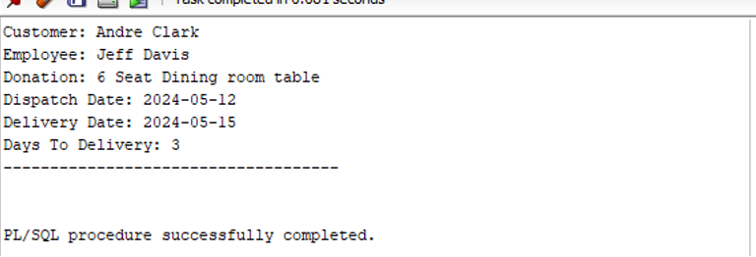

QUESTION 6

SET SERVEROUTPUT ON;

DECLARE

k_customer_name VARCHAR2(100);

k_customer_surname VARCHAR2(100);

k_total_spent NUMBER;

k_customer_rating VARCHAR2(20);

CURSOR INFO IS

SELECT c.FIRST_NAME, c.SURNAME, NVL(SUM(REPLACE(dn.PRICE, 'R ', '') * 1), 0) AS TOTAL_AMOUNT_SPENT

FROM CUSTOMER c

LEFT JOIN INVOICE i ON c.CUSTOMER_ID = i.CUSTOMER_ID

LEFT JOIN DONATION dn ON i.DONATION_ID = dn.DONATION_ID

GROUP BY c.CUSTOMER_ID, c.FIRST_NAME, c.SURNAME

HAVING NVL(SUM(REPLACE(dn.PRICE, 'R ', '') * 1), 0) >= 799;

BEGIN

FOR rec IN INFO

LOOP

k_customer_name := rec.FIRST_NAME;

k_customer_surname := rec.SURNAME;

k_total_spent := rec.TOTAL_AMOUNT_SPENT;

-- get the customer rating

IF k_total_spent >= 1500 THEN

k_customer_rating := '*';

ELSE

k_customer_rating := '';

END IF;

-- Display

DBMS_OUTPUT.PUT_LINE('Name: ' || v_customer_name);

DBMS_OUTPUT.PUT_LINE('Surname: ' || v_customer_surname);

DBMS_OUTPUT.PUT_LINE('Total Amount Spent: ' || TO_CHAR(v_total_spent, 'FM9999.99') || v_customer_rating);

DBMS_OUTPUT.PUT_LINE('------------------------------------');

END LOOP;

END;

Output:

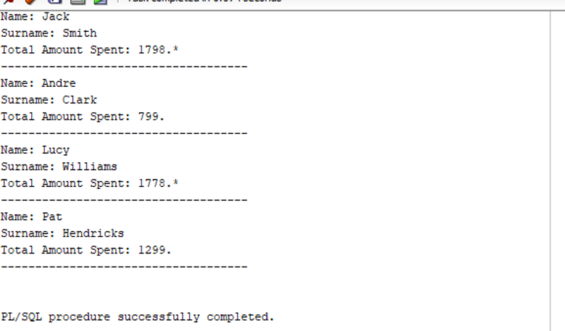

QUESTION 7

Q7.1

SET SERVEROUTPUT ON;

DECLARE

m_customer_name CUSTOMER.FIRST_NAME%TYPE;

m_employee_name EMPLOYEE.FIRST_NAME%TYPE;

m_donation DONATION.DONATION%TYPE;

m_dispatch_date DELIVERY.DISPATCH_DATE%TYPE;

m_delivery_date DELIVERY.DELIVERY_DATE%TYPE;

m_days_between NUMBER;

CURSOR INFO IS

SELECT c.FIRST_NAME, c.SURNAME, i.EMPLOYEE_ID, d.DELIVERY_NOTES, dn.DONATION, d.DISPATCH_DATE, d.DELIVERY_DATE

FROM INVOICE i

JOIN CUSTOMER c ON i.CUSTOMER_ID = c.CUSTOMER_ID

JOIN DELIVERY d ON i.DELIVERY_ID = d.DELIVERY_ID

JOIN DONATION dn ON i.DONATION_ID = dn.DONATION_ID;

BEGIN

-- Loop through the cursor

FOR rec IN INFO

LOOP

-- Assign values to variables

m_customer_name := cat.FIRST_NAME || ' ' || cat.SURNAME;

m_employee_name := cat.EMPLOYEE_ID; -- Assuming EMPLOYEE_ID holds the employee's first name

m_donation := cat.DONATION;

m_dispatch_date := cat.DISPATCH_DATE;

m_delivery_date := cat.DELIVERY_DATE;

-- Calculate days between dispatch and delivery

m_days_between := cat.DELIVERY_DATE - cat.DISPATCH_DATE;

-- Display the information

DBMS_OUTPUT.PUT_LINE('Customer: ' || m_customer_name);

DBMS_OUTPUT.PUT_LINE('Employee ID: ' || m_employee_name);

DBMS_OUTPUT.PUT_LINE('Donation: ' || m_donation);

DBMS_OUTPUT.PUT_LINE('Dispatch Date: ' || TO_CHAR(m_dispatch_date, 'YYYY-MM-DD'));

DBMS_OUTPUT.PUT_LINE('Delivery Date: ' || TO_CHAR(m_delivery_date, 'YYYY-MM-DD'));

DBMS_OUTPUT.PUT_LINE('Days Between: ' || m_days_between);

DBMS_OUTPUT.PUT_LINE('------------------------------------');

END LOOP;

END;

Sample output:

Q7.2

SET SERVEROUTPUT ON;

DECLARE

-- Declare a variable of type

m_donation_rec DONATION%ROWTYPE;

-- Cursor fetches data

CURSOR donation_cursor IS

SELECT * FROM DONATION;

BEGIN

-- Open the cursor

OPEN donation_cursor;

-- Fetch data and loop

LOOP

-- Fetching data into the variable

FETCH donation_cursor INTO m_donation_rec;

-- Exit loop if there is no more rows

EXIT WHEN donation_cursor%NOTFOUND;

-- Display values

DBMS_OUTPUT.PUT_LINE('Donation ID: ' || m_donation_rec.DONATION_ID);

DBMS_OUTPUT.PUT_LINE('Donator ID: ' || m_donation_rec.DONATOR_ID);

DBMS_OUTPUT.PUT_LINE('Donation: ' || m_donation_rec.DONATION);

DBMS_OUTPUT.PUT_LINE('Price: ' || m_donation_rec.PRICE);

DBMS_OUTPUT.PUT_LINE('Donation Date: ' || TO_CHAR(m_donation_rec.DONATION_DATE, 'YYYY-MM-DD'));

DBMS_OUTPUT.PUT_LINE('------------------------------------');

END LOOP;

-- Close cursor

CLOSE donation_cursor;

END;

Output:

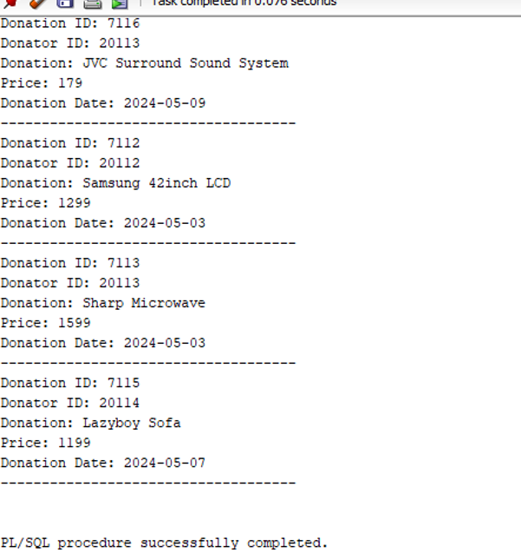

Q7.3

SET SERVEROUTPUT ON;

DECLARE

p_customer_id CUSTOMER.CUSTOMER_ID%TYPE := 99999;

-- The customer ID 99999 does not exist on the table

p_customer_name CUSTOMER.FIRST_NAME%TYPE;

BEGIN

-- Attempt to select customer

SELECT FIRST_NAME INTO p_customer_name FROM CUSTOMER WHERE CUSTOMER_ID = p_customer_id;

DBMS_OUTPUT.PUT_LINE('Customer Name: ' || p_customer_name);

EXCEPTION

WHEN NO_DATA_FOUND THEN

DBMS_OUTPUT.PUT_LINE('Error: No customer found with ID ' || p_customer_id);

END;

Output:

Q7.4

Source Code:

-- PL/SQL Block to create and handle a user-defined exception

SET SERVEROUTPUT ON;

DECLARE

m_customer_id CUSTOMER.CUSTOMER_ID%TYPE := 11011;

m_donation_amount DONATION.PRICE%TYPE := -100; -- Invalid donation amount

b_invalid_donation_amount EXCEPTION; -- Declare user-defined exception

BEGIN

-- Check for invalid donation amount

IF m_donation_amount < 0 THEN

RAISE m_invalid_donation_amount; -- Raise the exception

END IF;

-- If no exception, proceed with the logic

DBMS_OUTPUT.PUT_LINE('Valid donation amount: ' || m_donation_amount);

EXCEPTION

WHEN b_invalid_donation_amount THEN

DBMS_OUTPUT.PUT_LINE('Error: Invalid donation amount ' || m_donation_amount);

END;

Sample Output:

